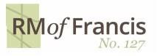

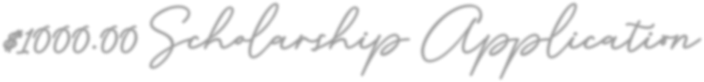

**ELIGIBILITY**

* Graduate of (Grade 12) 2025 Vibank Regional School or
* Homeschooled and schooling/residence within the RM of Francis
* Acceptance to an accredited technical institute, trade school or university

**HOW TO APPLY**

1. Submit a **completed application form** (this form) **and send to;**

**Attention Administrator – RM Student Scholarship 2025**

* [CAO@rmoffrancis.ca](mailto:CAO@rmoffrancis.ca) or
* Mail to: Box 36, Francis, SK S0G 1V0 or
* Drop off at PT NE 32 14 14 W2

1. Write **500 words or less** detailing a brief history describing any achievements, community involvement and/or demonstrated leadership that make you the best candidate for this award. **Attach a separate document or include within the email**.
2. Provide a copy of your most **recent transcripts**
3. Provide **proof of acceptance to accredited post-secondary school**, technical institute, trades or University.

**RM 127 SCHOLARSHIP APPLICATION DEADLINE SEPTEMBER 30th, 2025**

**IMPORTANT INFORMATION**

* Questions regarding the application process shall be directed to the administrator [cao@rmoffrancis.ca](mailto:cao@rmoffrancis.ca) by September 26th, 2025. Application accuracy will not be reviewed, and it is the sole responsibility of the applicant to submit a completed application.
* This scholarship is not eligible for those students who are attending school(s) outside the boundaries of the RM of Francis No. 127.
* You must be a grade 12 graduate of 2025 and attending a post-secondary school within 2025
* Proof of acceptance (enrollment) to post-secondary institutions typically should establish post-secondary commencement date.
* There is the potential for 2 (two) $1,000.00 scholarships to be awarded upon receipt of completed applications that are received by the **deadline date of September 30, 2025**
* **Successful applicants will be notified by October 15th, 2025**
* Information provided will be used solely for the purpose of determining eligibility and will not be retained on file after recipient(s) awarded.
* The RM of Francis No. 127 Council reserves the right to assess all applications and award the scholarships at their discretion.

**RM127 SCHOLARSHIP**

**APPLICATION FORM**

NAME (Applicant):

MAILING ADDRESS: ____________________________________________________________________________________

PHONE NUMBER:

Contact Email:

Attending Vibank Regional Home School - location ______________________________________

Post Secondary school accepted to: __________________________________ Program: ____________________________

PARENT’S NAME(S): __________ Contact Number: ____________________________

I ______________________acknowledge that with this application;

(Print name)

1. My name may be written in the RM of Francis No. 127 public meeting minutes and the award of the scholarship may be advertised by the RM of Francis No. 127 at their discretion on various media platforms including website and social media (picture may be taken of recipients receiving award).
2. I understand that any false statements on my application may negatively impact my eligibility for the scholarship.
3. I have read and understand the application process of eligibility, how to apply and important information provided within this application.

# Signature of Applicant: ________________________________ Date _______________________

**Signature of Parent/Guardian: __________________________ Date _______________________**